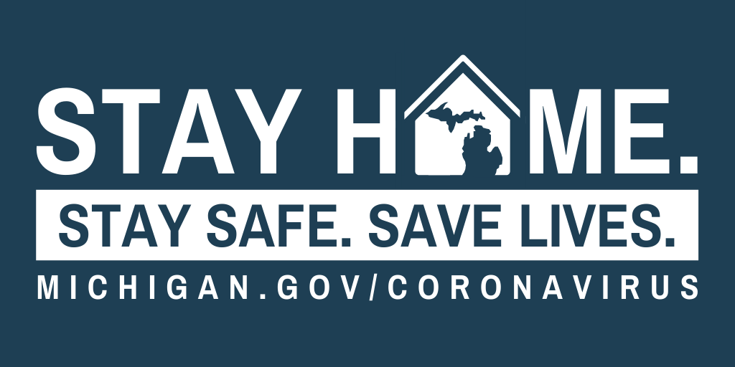
To combat the spread of COVID-19 in Michigan, Governor Whitmer signed the “Stay Home, Stay Safe” executive order. For at least the next three weeks, all Michigan businesses and operations must temporarily suspend in-person operations that are not necessary to sustain or protect life, and all Michiganders must stay in their homes unless they’re a part of that critical infrastructure workforce, engaged in an outdoor activity, or performing tasks necessary to the health and safety of themselves or their family, like going to the hospital or grocery store.
YOU CAN:
- Go to the grocery store or pick up take-out food.
- Go to the pharmacy to pick up a needed prescription.
- Engage in outdoor activities like walking, hiking, running, biking.
- Go to the hospital or secure any care necessary to address a medical emergency or to preserve your health or the health of a loved one.
- Fill your car with gas.
- Return to Michigan to a home or place of residence from outside the State.
- Leave the State for a home or residence elsewhere.
- Walk your pets and take them to the veterinarian for needed medical care.
YOU MAY NOT:
- Leave the home to work unless your employer designates you as a critical infrastructure worker.
- Participate in any public gatherings.
- Visit someone in the hospital, nursing home, or other residential care facilities (with limited exceptions).
- Go to the mall or to restaurants.
BUSINESSES THAT REMAIN OPEN FOR IN-PERSON WORK MUST TAKE AGGRESSIVE STEPS TO MINIMIZE THE VIRUS’S SPREAD. THEY MUST:
- Promote remote work to the fullest extent possible.
- Restrict the number of workers present in-person on the job.
- Keep employees at least six feet from one another to the maximum extent possible and enabling social distancing for customers who are standing in line.
- Any other social distancing practices and mitigation measures recommended by the Centers for Disease Control.
Information around this outbreak is changing rapidly. The latest information is available at Michigan.gov/Coronavirus and CDC.gov/Coronavirus.
For those who have questions about the state’s actions to mitigate the spread of coronavirus, please call the COVID-19 Hotline at 1-888-535-6136 between 8AM - 5PM daily.

